
American International University – Bangladesh
Faculty of Engineering
Department of EEE & CoE

MICROPROCESSOR & EMBEDDED SYSTEM PROJECT PROPOSAL FORM
SEMESTER: Fall 2022-2023

PROJECT TITLE: IoT – Based Smart Poultry Farm & Fish Farming System.
Survey to develop a process for complex engineering problems considering cultural and societal factors (use pie chart):

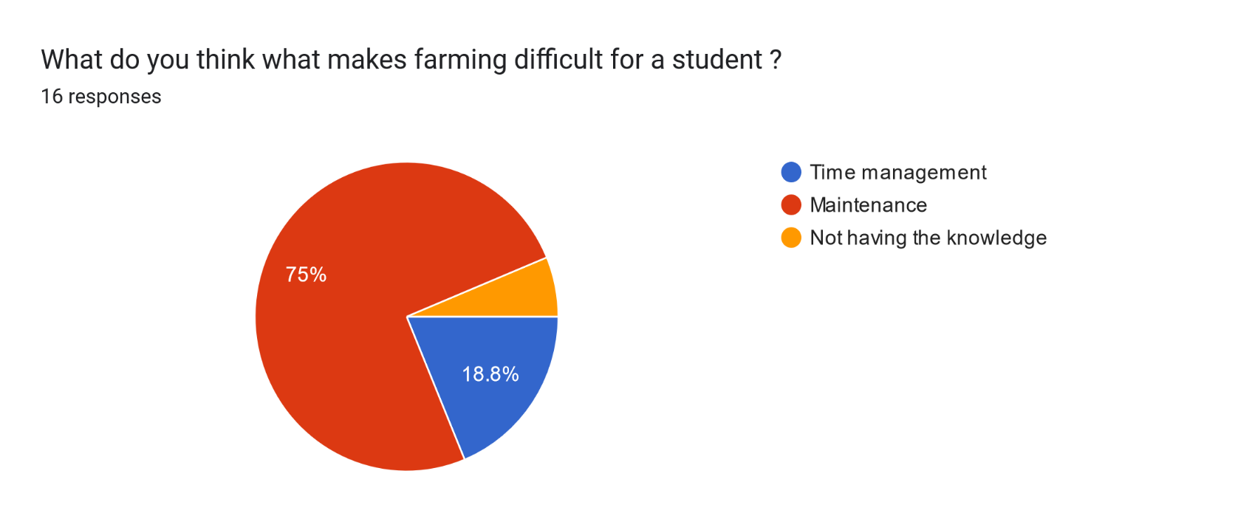
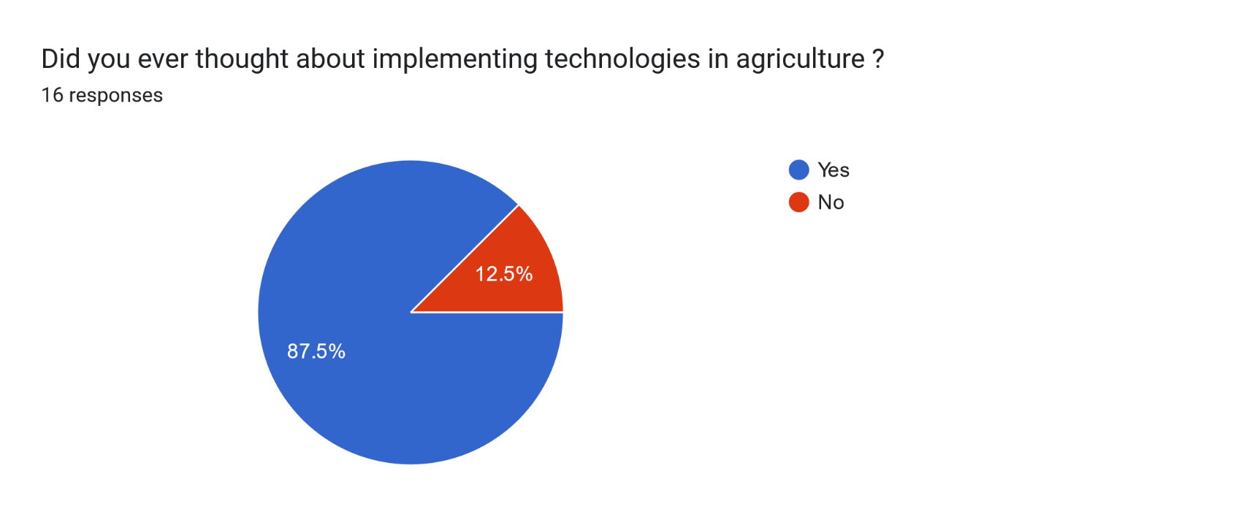
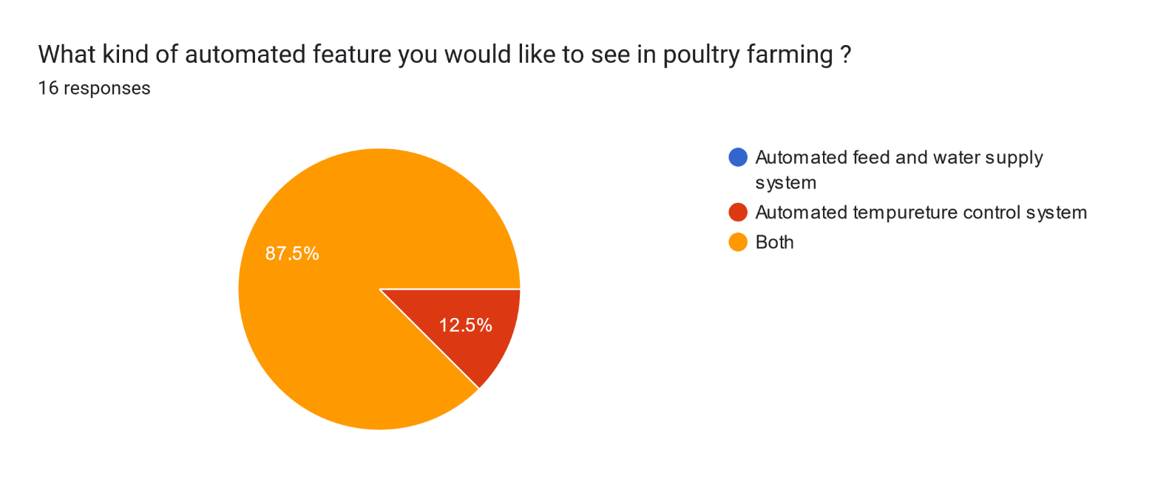
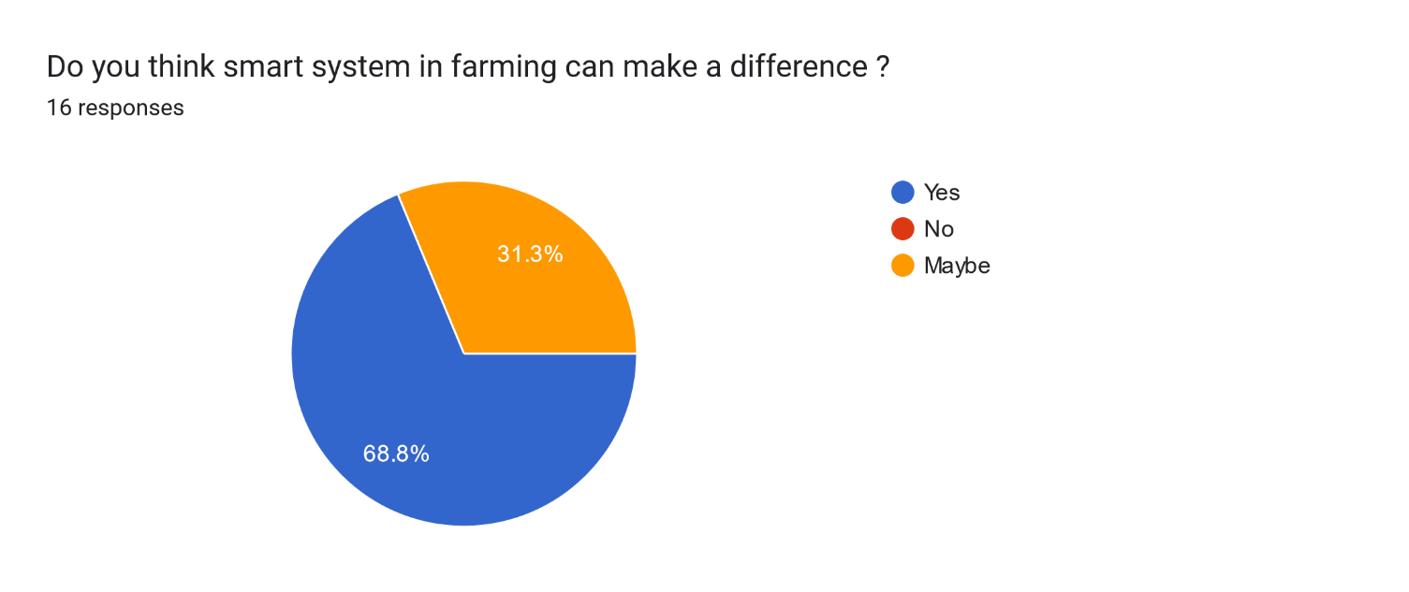
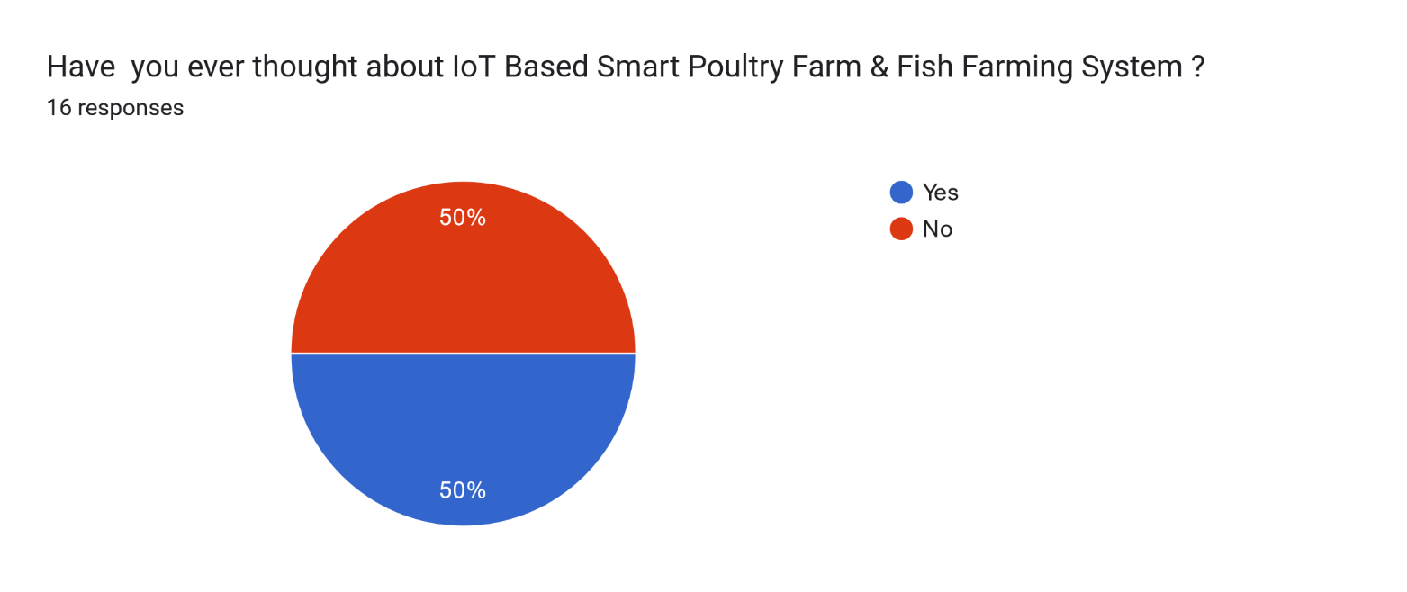
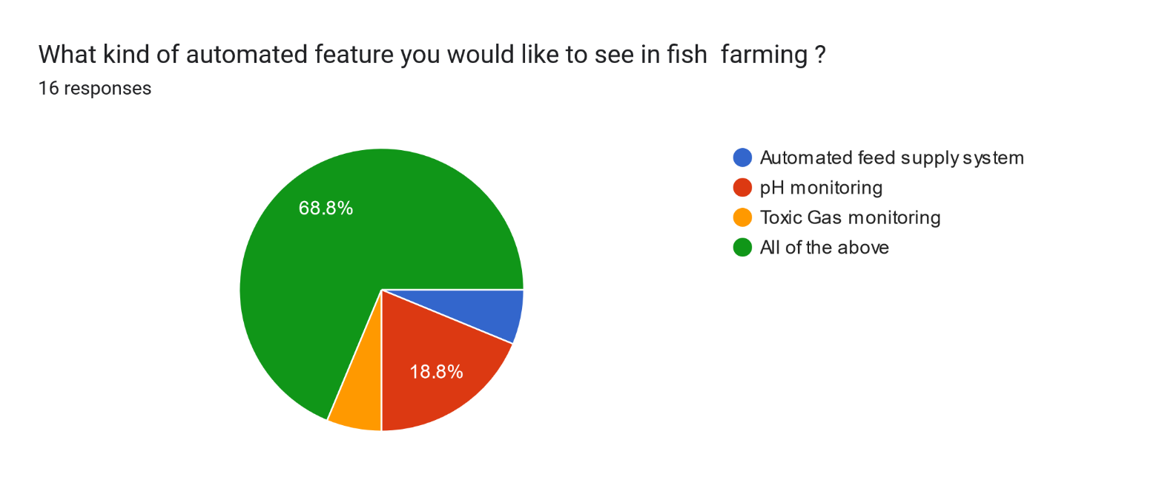
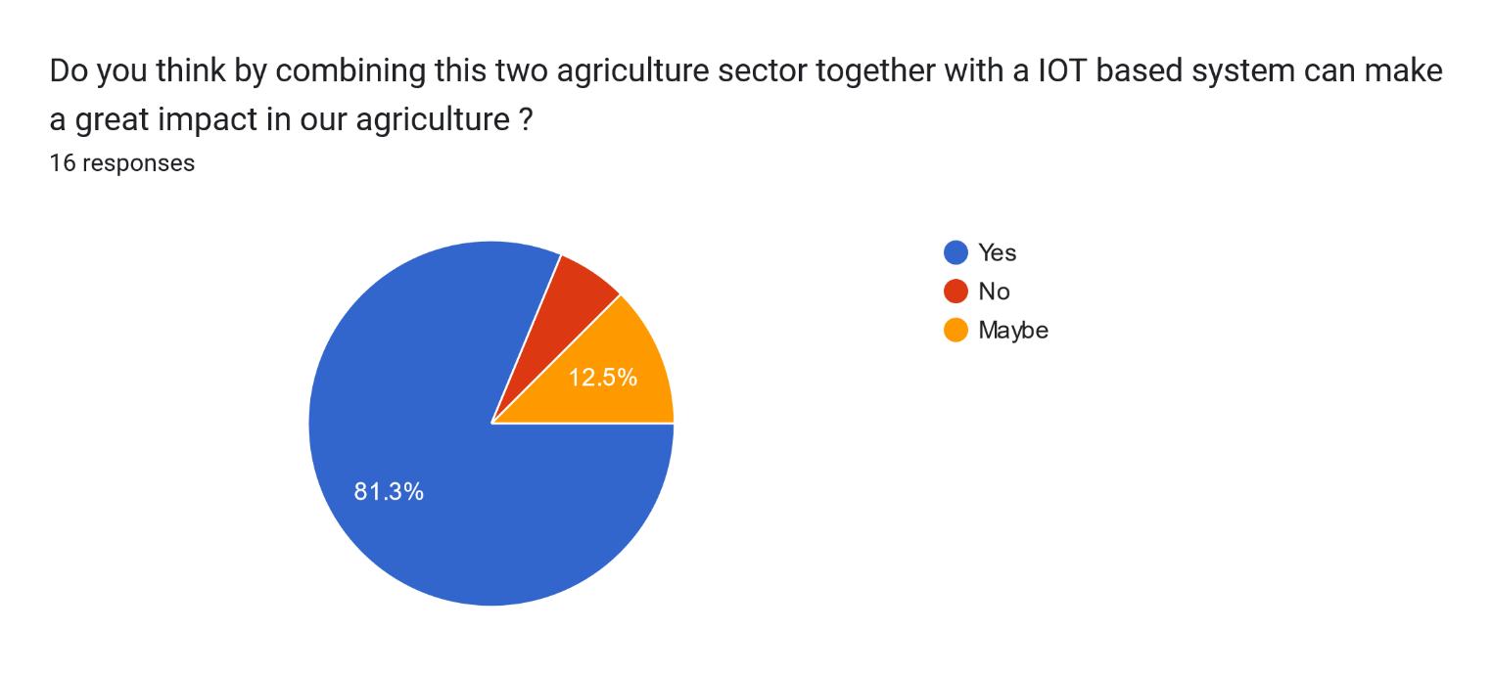
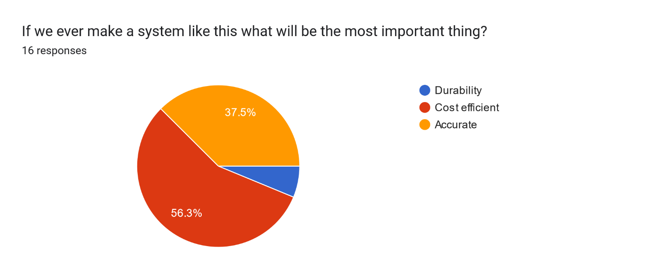
GOALS AND BENEFITS OF THE PROJECT:
We all know that agriculture is one of the largest sectors in our country. But it is a big reason to worry that the people of Bangladesh still use traditional farming. Also, some students want to do farming, but for lack of time or some issue, they need more time. So here we will implement an IoT-based system using Arduino Uno that will help to farm. The main goal of this project is
- To create an automated system that will maintain poultry and fish farms at the same time
- This system will automatically provide feed and water to chickens and feed to fish.
- Temperature control in poultry farm.
- pH control in a fish farm.

So, this project significantly reduces one's time and effort in farming. Also, there is some benefit
- Can monitor and control farms virtually
- Chicken and fish will grow in a controlled environment so that the production rate will rise.

EXPERIMENTAL BLOCK DIAGRAM:

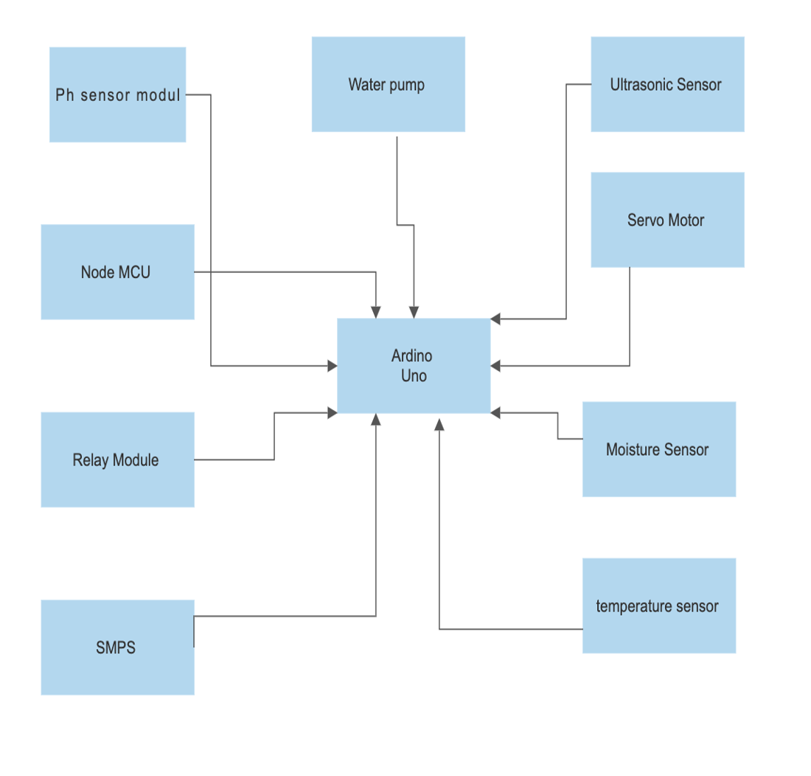

PROJECT TIMELINE (GANTT CHART):

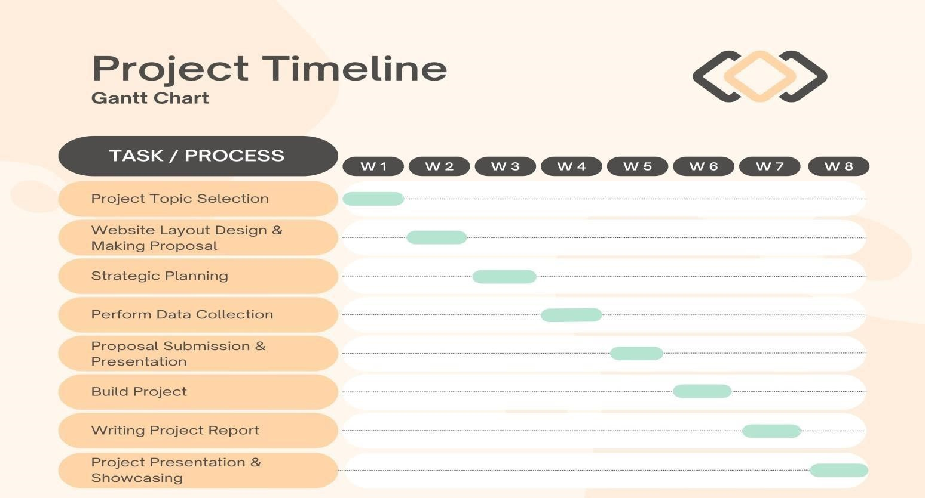

REFERENCES:

- Llaria, A.; Terrasson, G.; Arregui, H.; Hacala, A. Geolocation and monitoring platform for extensive farming in mountain pastures. In Proceedings of the 2015 IEEE International Conference on Industrial Technology, Seville, Spain, 17–19 March 2015.

- C. Kamienski, J.-P. Soininen, M. Taumberger, R. Dantas, A. Toscano, T. S. Cinotti, R. F. Maia, and A. T. Neto, ‘‘Smart water management platform: IoT-based precision irrigation for agriculture,’’ Sensors, vol. 19, no. 2, p. 276, 2019.
- T. Ojha, S. Misra, and N. S. Raghuwanshi, ‘‘Wireless sensor networks for agriculture: The state-of-the-art in practice and future challenges,’’Comput. Electron. Agricult., vol. 118, pp. 66–84, Oct. 2015.
- O. Elijah, T. A. Rahman, I. Orikumhi, C. Y. Leow, and M. N. Hindia, ‘‘An overview of Internet of Things (IoT) and data analytics in agricul-ture: Benefits and challenges,’’ IEEE Internet Things J., vol. 5, no. 5, pp. 3758–3773, Oct. 2018.

FOR FACULTY USE ONLY
COMMENTS BY COURSE TEACHER:

COURSE TEACHER’S NAME COURSE TEACHER’S SIGNATURE DATE

GROUP MEMBERS
(Maximum 8 students are permitted to carry out a single Project. However, depending on the capability of the students, 4 students may be allowed but not less than that)

NAME: EASHITA ISLAM  ID: 20-42008-1  PROGRAM: CSE  EMAIL: 20-42008-1@student.aiub.edu | NAME: SABIHA KHAIR OHI  ID: 20-41905-1  PROGRAM: CSE  EMAIL: 20-41905-1@student.aiub.edu
NAME: RAKIN SAD AFTAB  ID: 20-41991-1  PROGRAM: CSE  EMAIL: 20-41991-1@student.aiub.edu | NAME: RIJOAN FARDOUS  ID: 20-41943-1  PROGRAM: CSE  EMAIL: 20-41943-1@student.aiub.edu
NAME: SULTANUL ARIFEEN HAMIM  ID: 20-42017-1  PROGRAM: CSE  EMAIL: 20-42017-1@student.aiub.edu | NAME: SHAHARIYER SHAMS JIM  ID: 20-43173-1  PROGRAM: CSE  EMAIL: 20-43173-1@student.aiub.edu
NAME: TAUSIFUR RAHMAN
ID: 20-42763-1
PROGRAM: CSE
EMAIL: 20-42763-1@student.aiub.edu
REMARKS (for OFFICE use only)

